Rest and Spring Data JPA Movie Application
Create a “Movie App” wherein movies could be maintained according to genres like Fiction, Drama and Satire. There is also a search option allowing to search for movies.
Use Movies.java

Create Spring Rest full application to perform following operation on Movie from database
    - Add Movie
    - Delete Movie
    - Search All Movies
    - Search Movie by Category
    - Update Movie Info

Refer below screen shot for reference
Note Do not Create UI here.
This UI will be created after covering Angular/React
Test your Spring Resfull web service using Postman

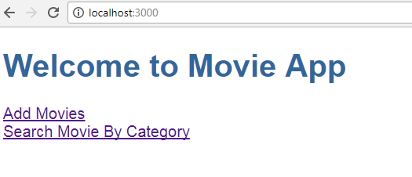

- When the user clicks on “Add Movies” -> Allows a User to add a movie.
The user can add movie(s) depending on Genre (drop-down list loaded with values [Drama, Fiction, Satire])
The user could add multiple movies. On Adding Movies will be added in Database with the help of Spring Web services (Restful). Use Spring restful with JPA concept Refer below screen shot:

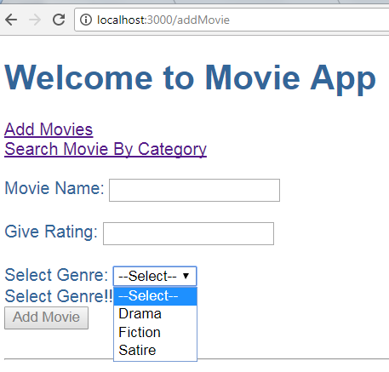

Refer below screens for validations:

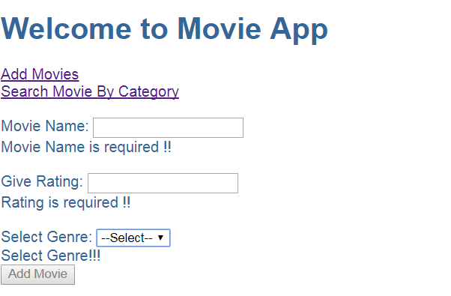

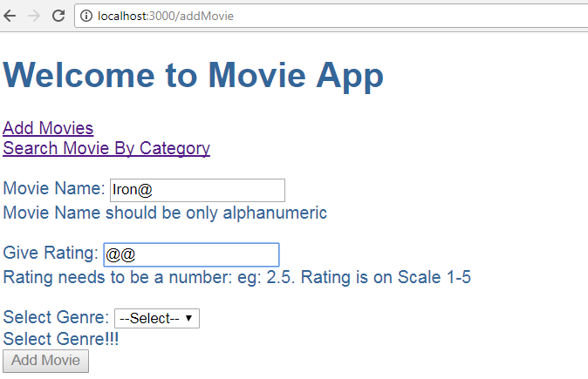

- When the user clicks on “Search Movie By Category” -> Allows user to search movie(s) by Category. [Depending on Genre (Drama,Fiction,Satire)]

There could be more than one movies depending on same Genre. Refer below screen shots:

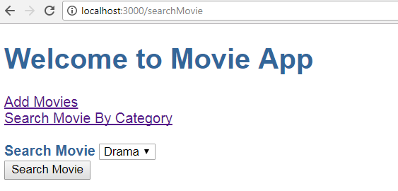

Thus if Searching Movie on ‘Drama’ displays below Result:
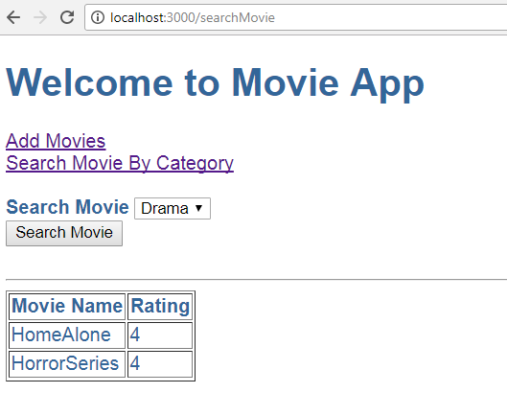

Thus if Searching Movie on ‘Fiction’ displays below Result:
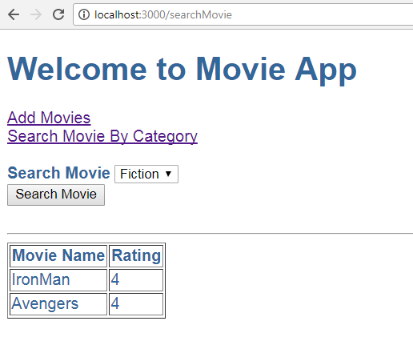

Note:
- In above assignment movies are added via “Add Movies” and Searched via “Search Movie By Category”. These are different components.
- Make use of Angular .
- Make use of services.
- Make use of Router Module. Which should be created as a separate module and included in the main App Module.
- Use Spring restful & JPA concept to add movies & search movies.
- All adding & searching movies done through database

Problem Statement 2: Building a CRUD API for a Blogging Platform using Spring Boot

Develop a Spring Boot Rest API for managing blog posts on a real-time blogging platform, allowing users to perform CRUD operations on their posts.

Requirements:

- Create, Read, Update, and Delete blog posts.
- Implement user authentication for creating and updating posts.
- Retrieve a list of all blog posts or filter by user.
- Include validation for post content length and required fields.

Operations to Perform:

- Create a new blog post
- Retrieve a list of all blog posts
- Retrieve a specific blog post by ID
- Update an existing blog post
- Delete a blog post
- Implement user authentication for create and update operations

Code Stub:

// Code for Blog Post CRUD Operations

// Create a new blog post
@PostMapping("/posts")
public ResponseEntity<String> createPost(@RequestBody PostDTO postDTO) {
// Implementation
}

// Retrieve a list of all blog posts
@GetMapping("/posts")
public ResponseEntity<List<PostDTO>> getAllPosts() {
// Implementation
}

// Retrieve a specific blog post by ID
@GetMapping("/posts/{postId}")
public ResponseEntity<PostDTO> getPostById(@PathVariable Long postId) {
// Implementation
}

// Update an existing blog post
@PutMapping("/posts/{postId}")
public ResponseEntity<String> updatePost(@PathVariable Long postId, @RequestBody PostDTO postDTO) {
// Implementation
}

// Delete a blog post
@DeleteMapping("/posts/{postId}")
public ResponseEntity<String> deletePost(@PathVariable Long postId) {
// Implementation
}

// User Authentication for Create and Update Operations
// ... (Using Spring Security features)
```

Sample Input:

- Create Post: { "title": "Spring Boot REST API", "content": "A detailed guide on building REST APIs with Spring Boot" }
- Update Post: { "title": "Updated Title", "content": "Updated content" }

Sample Output:

- Create Post: { "message": "Post created successfully", "postId": 1 }
- Update Post: { "message": "Post updated successfully" }

